Access to Imagine Math

1. Step 1: Log in Clever
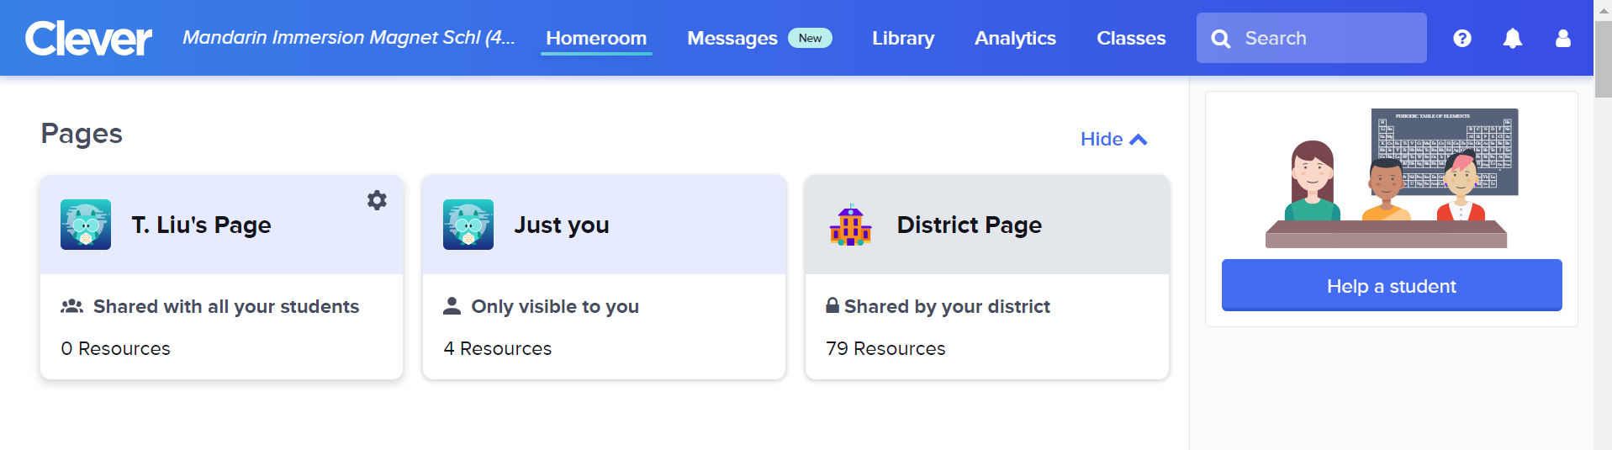

2. Scroll down and find math section, you’ll see “Imagine Math” app.
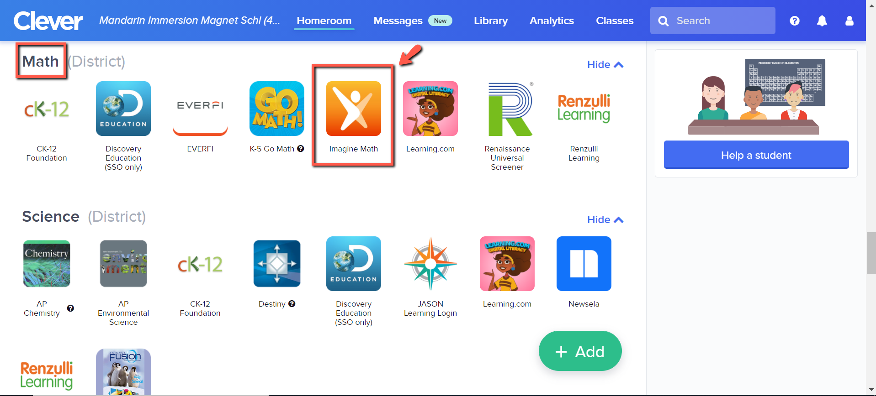

3. When students log in, they’ll be asked to complete their 1st benchmark.

