How to access to homework on Ontrack
First, go to “OnTrack”
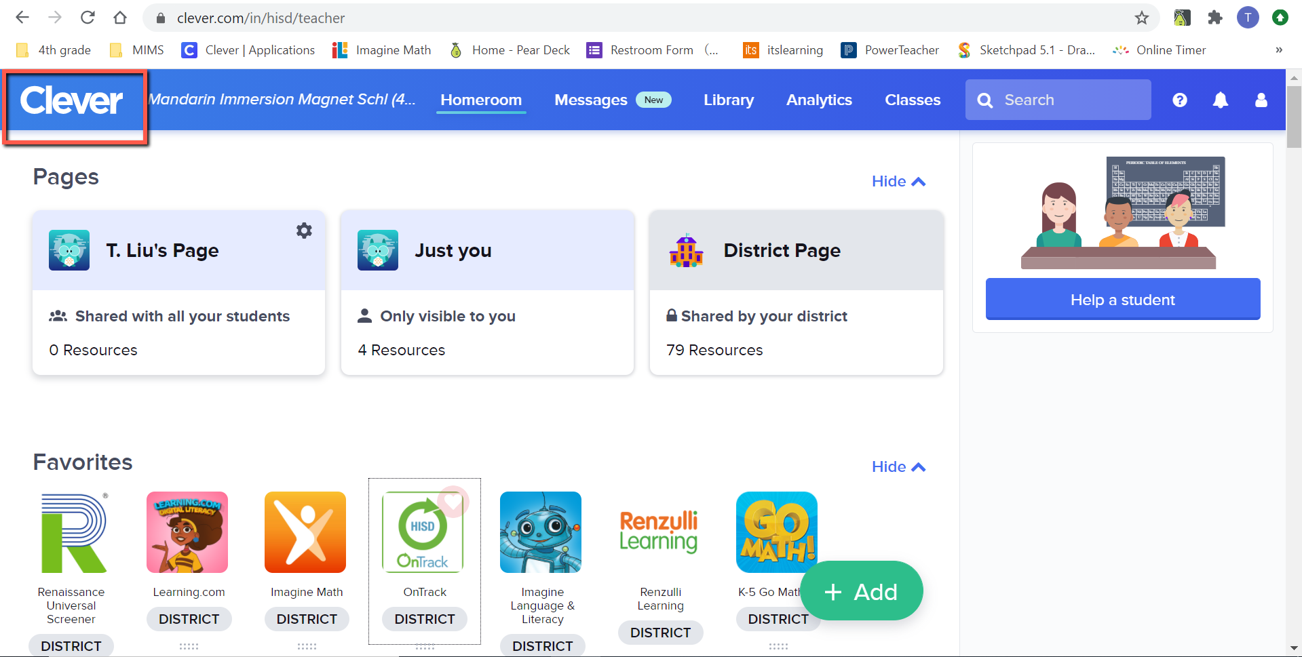

Find section: assessment. That’s where you can find “OnTrack”
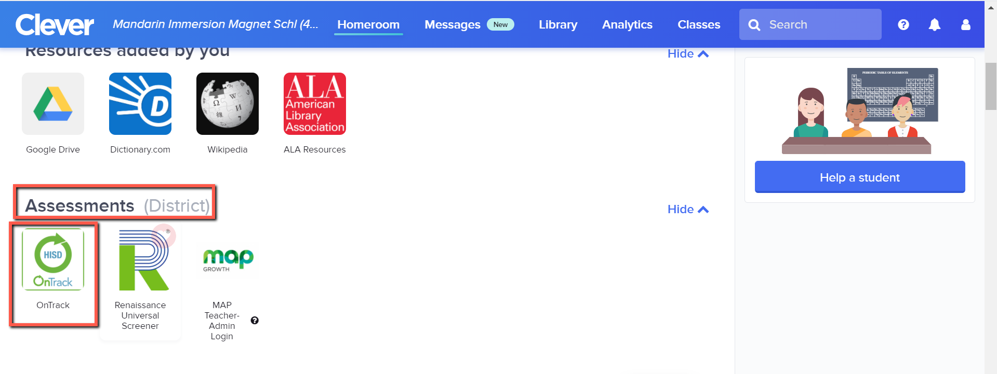

Click “OnTrack”, it’ll lead you to the main page. Click “assessment” to find the homework.

